

**Time:** 50 minutes

**Marks:** / 46 marks

**11 Essentials Unit 2 Test**

**Calculator Assumed**

**Allowed: 1 page double sided notes, Ruler**

**Name:**

**MULTIPLE CHOICE [7 marks]**

**1** The ratio of shaded parts to unshaded parts in the picture below is:



**A** 7 : 8 **B** 7 : 15

**C** 8 : 7 **D** 8 : 15

**E** 15 : 7

**2** The ratio of total parts to shaded parts in the picture above is:

**A** 7 : 8 **B** 7 : 15 **C** 8 : 7

**D** 8 : 15 **E** 15 : 7

**3** Which of the following is *not* equivalent to 8 : 12?

**A** 2 : 3 **B** 6 : 8 **C** 4 : 6

**D** 10 : 15 **E** 16 : 24

**4** Holly was 108 cm tall when she turned 5 years old, and 162 cm when she turned

14 years old. Her average rate of growth is:

**A** 5 cm/year **B** 6 cm/year **C** 7 cm/year

**D** 8 cm/year **E** 9 cm/year

**5** Maria can touch type 150 words in 3 minutes. How many words can she type in 7 minutes?

**A** 200 words **B** 250 words **C** 300 words

**D** 350 words **E** 400 words

**6** Half an hour, converted to seconds, is:

**A** 36 seconds **B** 180 seconds **C** 360 seconds

**D** 1800 seconds **E** 3600 seconds

**7** Written in 24-hour time, 5:45 pm is:

**A** 1345 **B** 1745 **C** 0545

**D** 1545 **E** 1945

**SHORT ANSWER [39 marks]**

**Question 1 [2 marks]**

Complete this two way table:

|  |  |  |  |
| --- | --- | --- | --- |
|  | **YES** | **NO** | **TOTAL** |
| **FEMALES** | 14 | 26 |  |
| **MALES** |  | 13 |  |
| **TOTAL** |  |  | 100 |

**Question 2 [5 marks]**

This graph shows the stopping distances for cars on different surfaces.



a) Estimate the stopping distances for cars travelling in the following conditions.

 i) snow at 60 km/h

ii) gravel at 110 km/h

b) What are the three possible road conditions for a stopping distance of 120 metres?

c) Approximately how much further does it take to stop on ice than a dry road when you are travelling at 80 km/h?

d) Approximately how much further does it take to stop from 110 km/h than at 60 km/h on a wet road?

**Question 3 [1, 1 = 2 marks]**

When there was a cyclone in Queensland, the price of bananas went up. They cost $48.60 for 9 kilograms.

1. What is the price per kilogram?
2. How much would it cost to buy 4 kilograms?

**Question 4 [5 marks]**

Milly entered the shotput at an athletics carnival. Her 14 distances are shown below (in cm):

415 412 407 413 421 405 419 420 409 405 420 404 417

Arabella has also entered the shotput. She recorded the following distances (in cm):

406 414 409 413 419 414 403 423 412 409 415 426 419

Draw a back-to-back stem-and-leaf plot for their distances. Who is better at shotput?, Explain why.

**Question 5 [2, 1 = 3 marks]**

The ratio of boys to girls in Year 11 is 5 : 6. There are 72 girls in Year 11.

1. How many boys are there in Year 11?
2. What is the total number of students in the year level?

**Question 6 [5 marks]**

Draw a boxplot for the set of data below:

13 22 13 30 15 17 10 22 16 35 7

**Question 7 [2, 1 = 3 marks]**

The scale is 1 : 1000. Calculate the real life-lengths of each feature on the map:

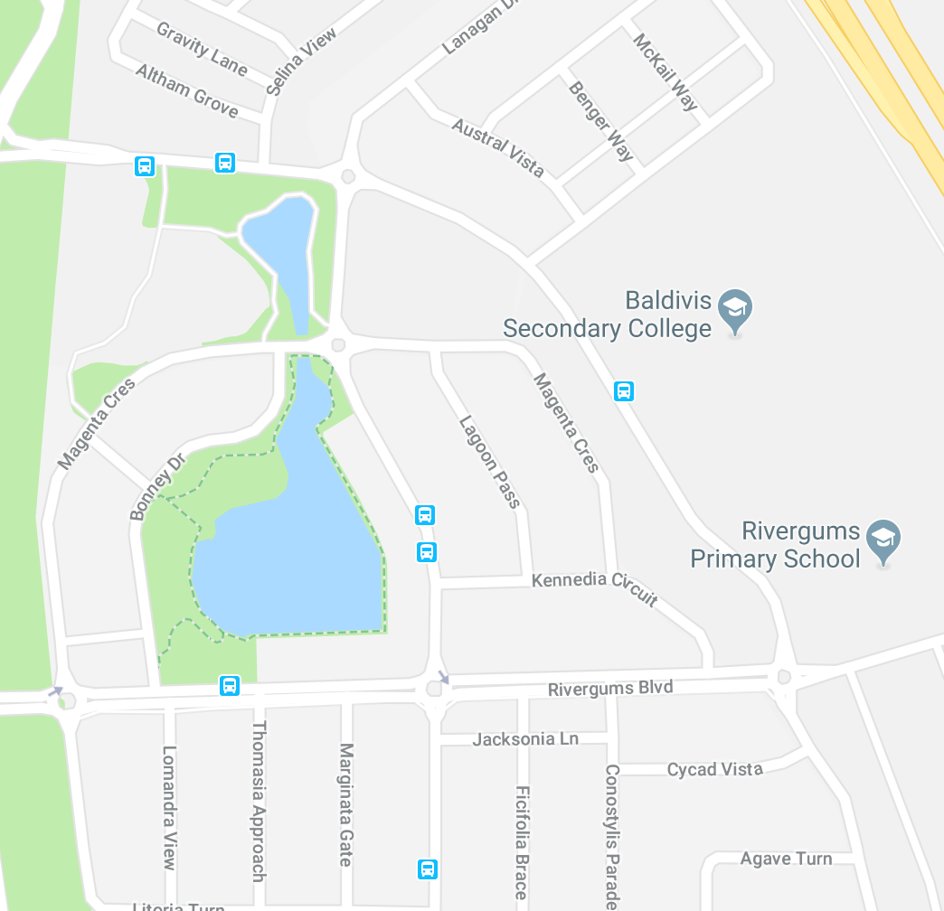

1. The width of the lake
2. If Tommy walks at a speed of 5m per minute, how long did it take him to walk to school?

**Question 8 [8 marks]**

Answer the following percentage questions, showing all working:

1. What percentage of $48 is $3?
2. At the start of 2015, you earned $350 per week in your job. If you first got a 4% pay rise and later got a 3% pay rise, how much do you now earn each week?
3. A plumber’s quote is $350 before GST. What is the total amount you will have to pay, including the 10% GST?
4. If $4500 is invested for two and a half years and it earns $528.75 interest, what is the interest rate per annum?

**Question 9 [6 marks]**

Daniel has moved out of home to live in a unit. He needs to be at work by 8:30am and has to catch a bus to a station and then a train. His walk from home to the bus stop takes 2 minutes. The bus trip takes 15 minutes and buses leave every 15 minutes from 6:00 am. The train trip takes 10 minutes and trains leave every 20 minutes from 6:05am. Daniel’s workplace is a 5 minute walk from the station. What is the latest time Daniel can leave home and still get to work on time?